TRAINING REPORT
ON Advanced Python
SUMMER INTERSHIP
Submitted to
Faculty of Computers and Artificial Intelligence
In partial fulfillment of the requirements
for the award of the degree
BACHELOR OF Computer Sciences
(Semester - IV)

Place: Public service center
Date: 23/9/2023
Submitted by: Abdelhaq Adel
Student’s Name: Abdelhaq Adel
Student’s Signature: abdelhaq
ID: 2031032

ACKNOWLEDGEMENTS
Note to Students:
CONTENT
CHAPTER 1: INTRODUCTIOM ON TRAINING

CHAPTER 2: basics of python
- Variables defination
- Arithmetic operations
- Comparison operators
- Data Types
- Rando numbers
- If Statements
- While loops
- For loops
- Variables
- Functions
- Data Structures

CHAPTER 3: NumPy library

- Creating NumPy Arrays.
- NumPy Attributes.
- Creating Arrays Using Methods.

CHAPTER 4: Pandas library

- Read CSV Files.
- Series.
- Data Frame.
- Functions

CHAPTER 5: Matplotlib library

1. Plotting
2. Scatter
3. Bars
4. Pie charts

CHAPTER 6 pillow (Image library)

Chapter 1: introduction on python
Chapter 1: Python basics

2.1 Variables definition
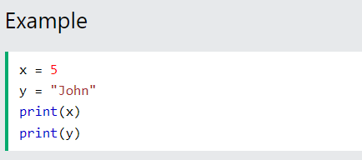

  - Arithmetic Operations
1- adding numbers in python 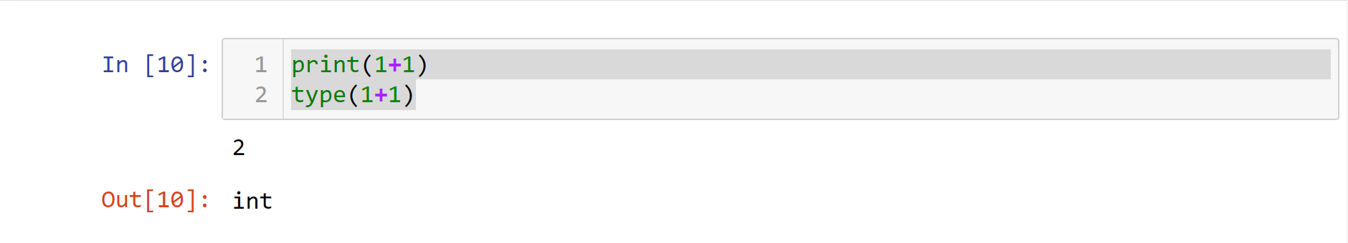
2- dividing numbers in python
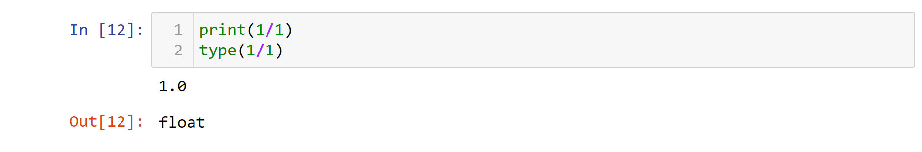
3- multiplying strings by a scaler in python
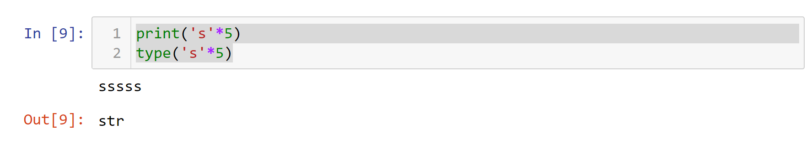
4- adding a number to a string in python
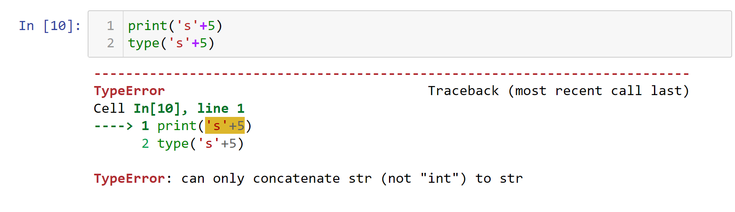
2.3 Comparison Operators
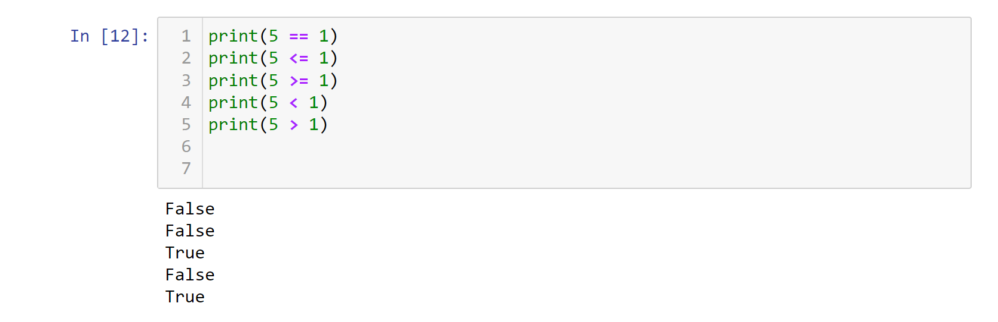
2, 4 Data Types
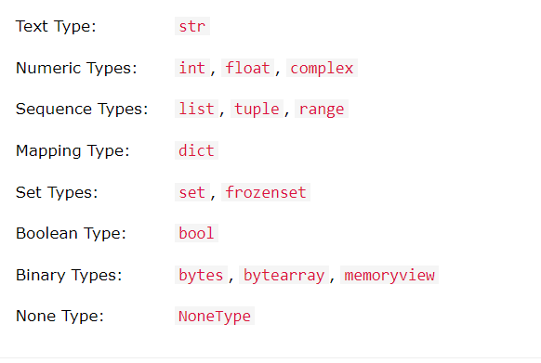
- We can get the data type of any object by using the type() function:
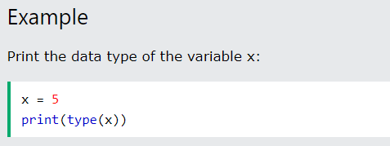
2, 6 If Statements
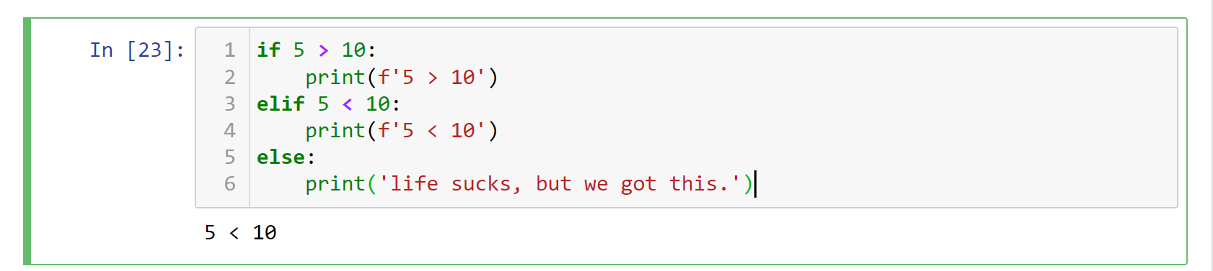
2, 7 While loops
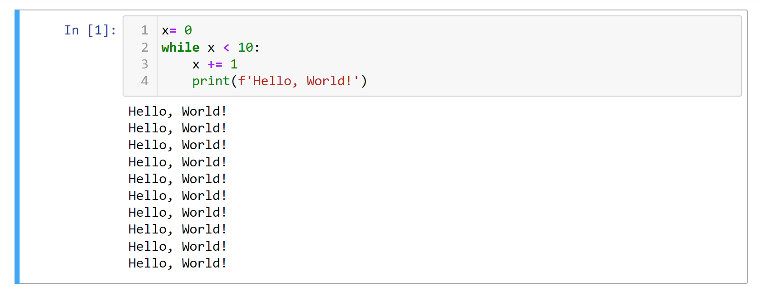
2, 9 Variables
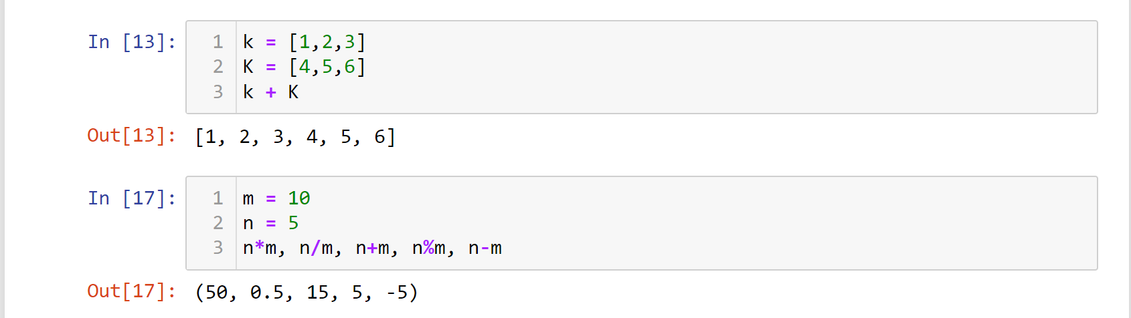
2, 10 Functions
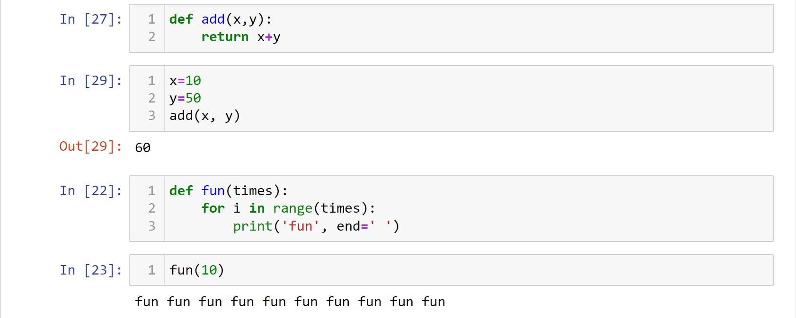
2, 11 Lists
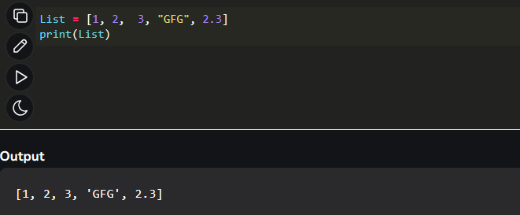
some operations in list:
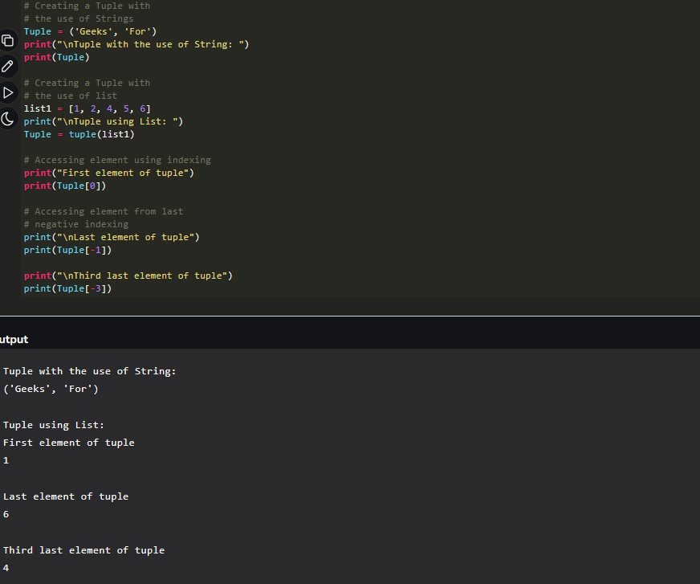

Sets
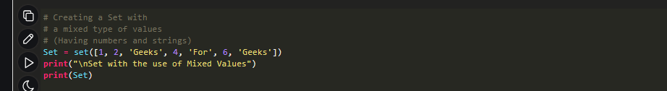
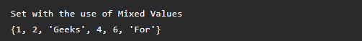

Dictionaries
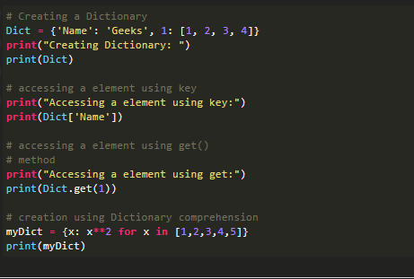
All libraries :
Chapter 3,1:(NumPy)
3.1 Creating NumPy arrays
NumPy is a Python library used for working with arrays.
This library for creating a NumPy array using the np.array method.
First importing NumPy
3.2 NumPy Attributes, functions:
Some methods in NumPy library
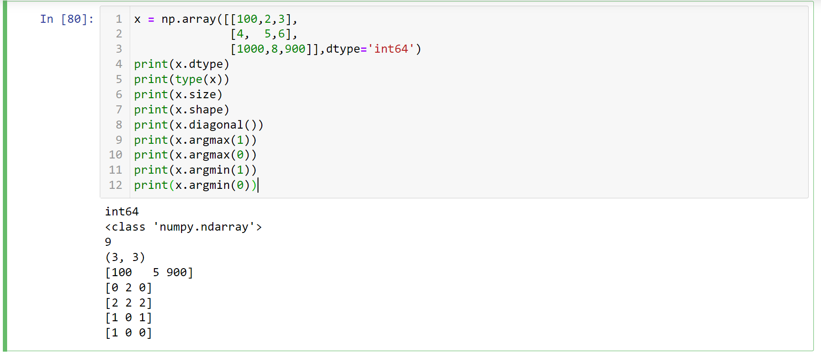
3.3 Creating NumPy arrays using methods
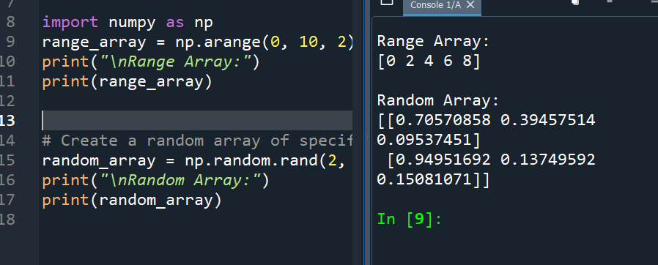
Chapter 4,1(Pandas)
Pandas is a Python library used for working with data sets.
It has functions for analyzing, cleaning, exploring, and manipulating data.

4.1 Reading CSV Files
Using pd.read_cv method we can read any file by Write the file name
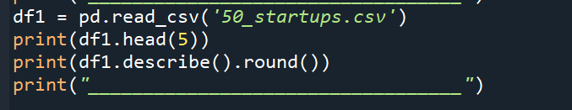
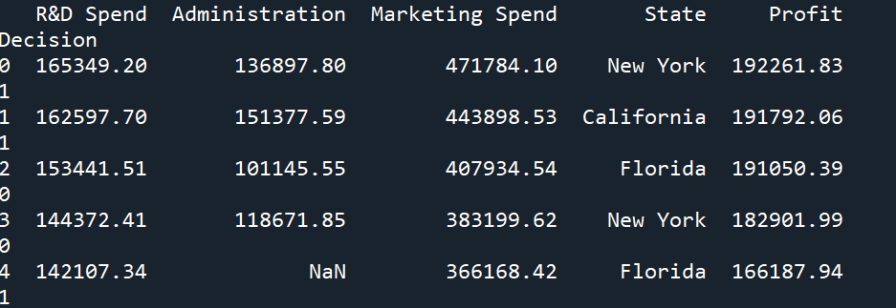

4.2 Series
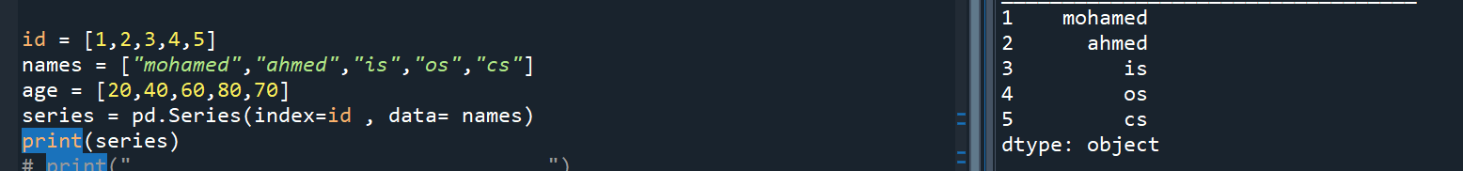

4.3 Data Frame
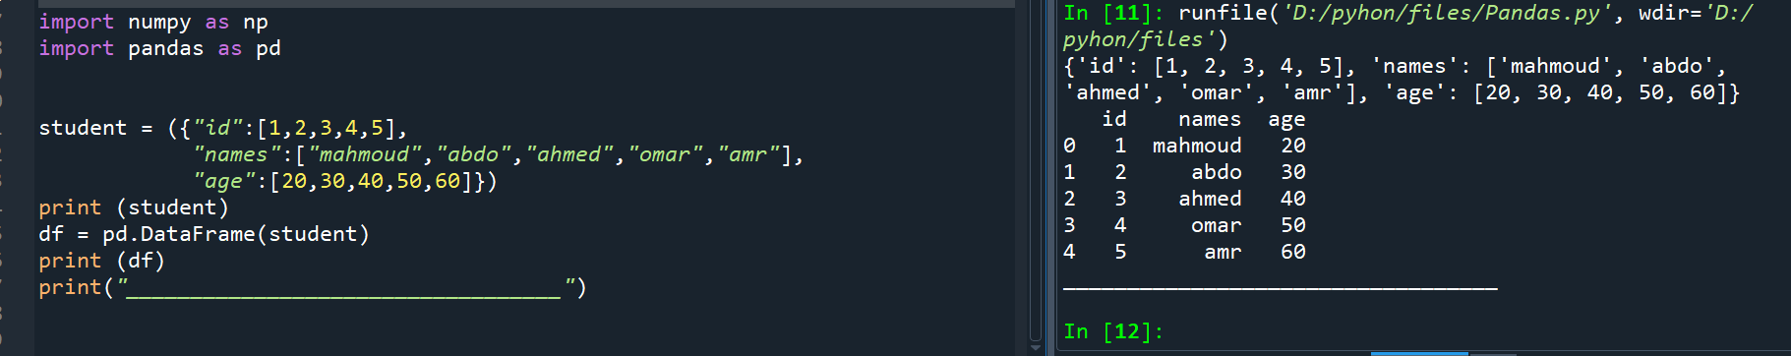

4.4 Some Functions in pandas

We can make some operations to this file :
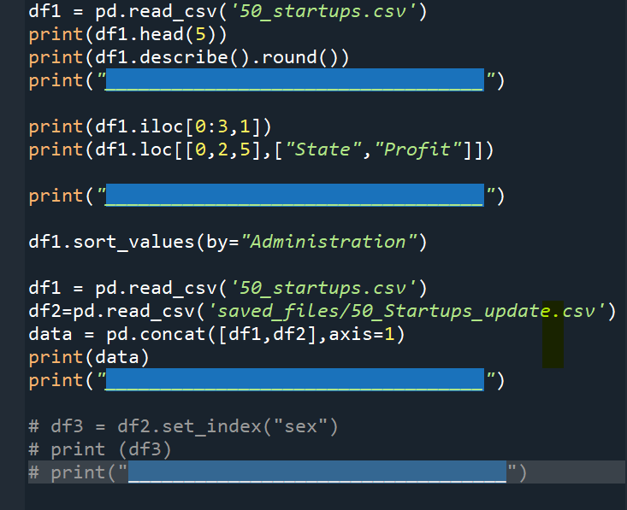

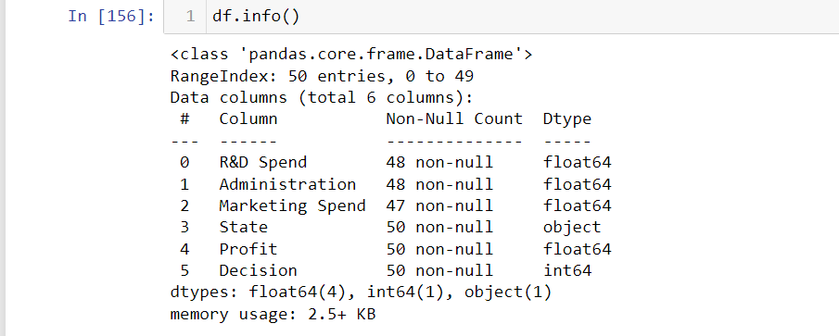
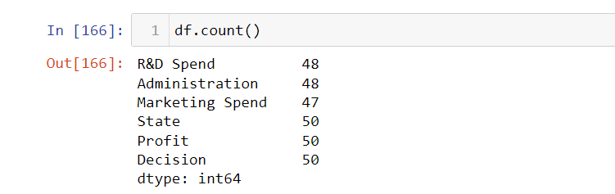
Chapter 5,1(Matplotlib)
Pie

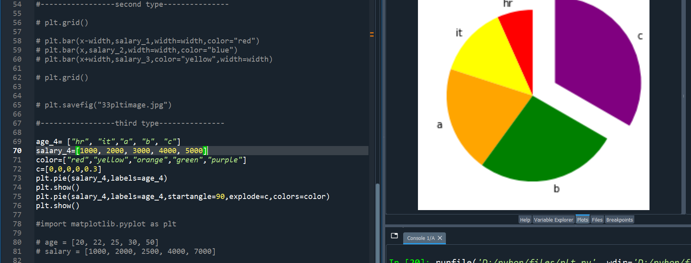
plot
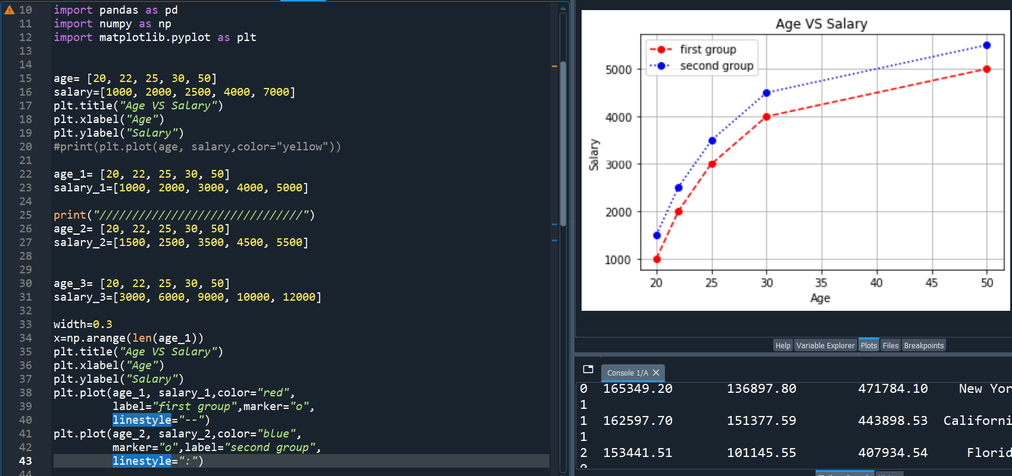

Scatter Plot
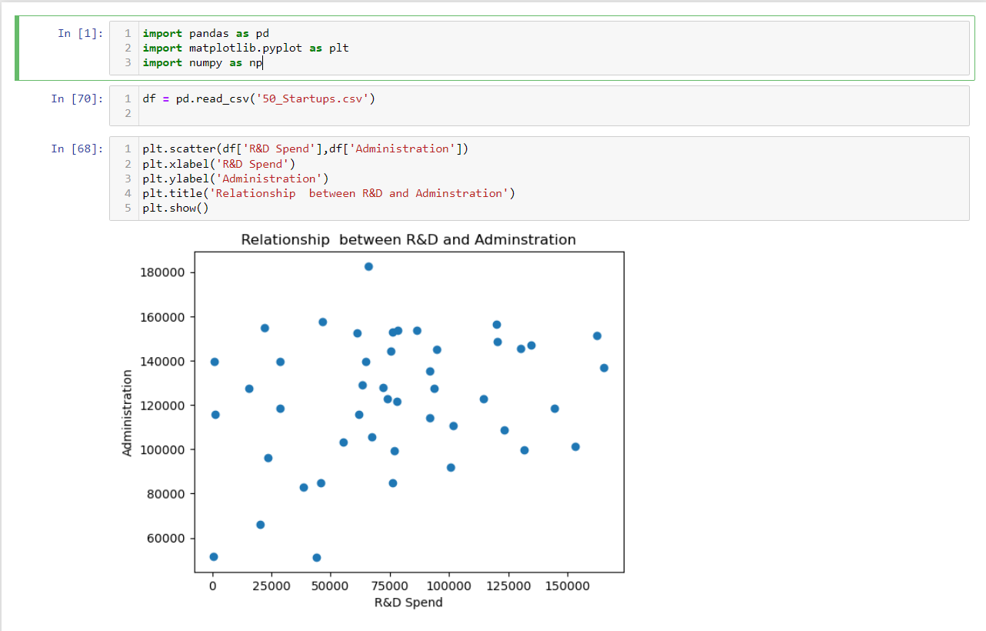
Histogram 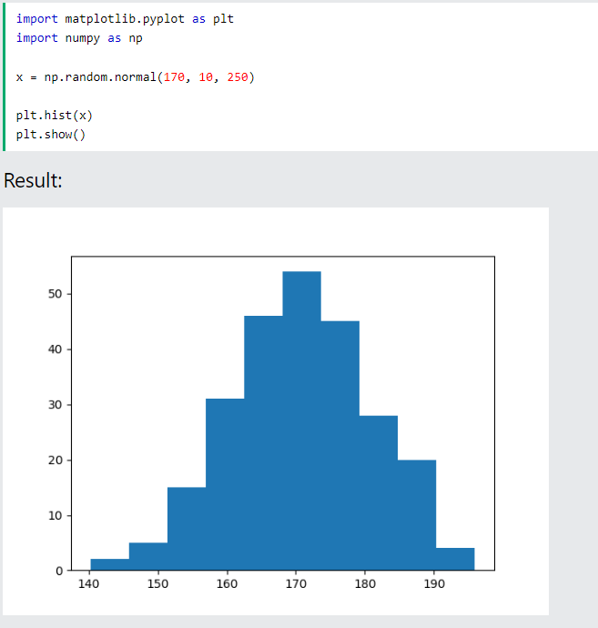

Bars
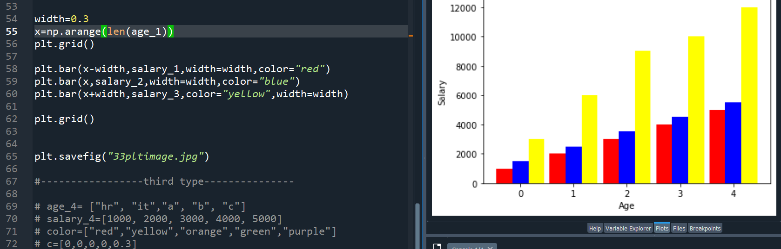

CHAPTER 6 pillow

- Import image library :
- 2-using some methods to make some operation on this image
- Crop (cutting of image)
- Rotate (to rotate the image by the grade )
- Transpose (change rotate)
- Convert (edit color of image)
- Median (add filter to image)

From PIL import image

